Jenkins installation steps:
yum install java-1.8.0
yum update –y
wget -O /etc/yum.repos.d/jenkins.repo http://pkg.jenkins-ci.org/redhat/jenkins.repo ----download the package
rpm -import http://pkg.jenkins-ci.org/redhat/jenkins-ci.org.key
download the key
yum install jenkins –y
service Jenkins start
service Jenkins stop
service Jenkins status
chkconfig --add jenkins
or
systemctl start Jenkins.service
systemctl enable Jenkins.service

/etc/sysconfig/Jenkins ---we can change the port for Jenkins here

Rpm package downloaded to local
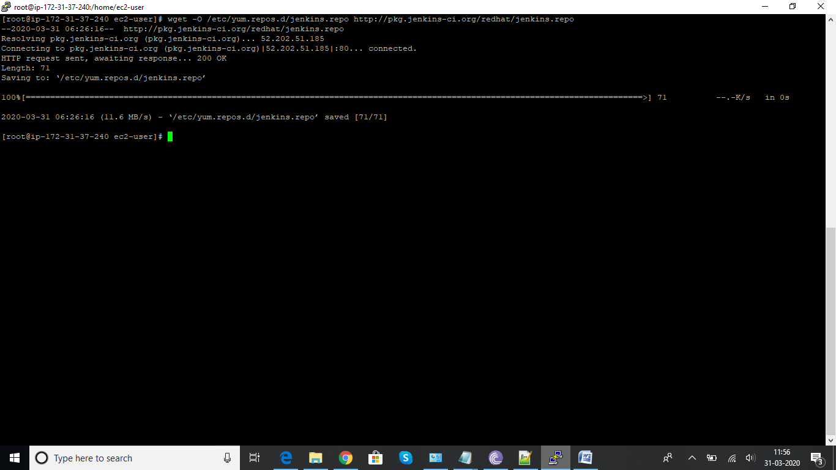

Jenkins installing
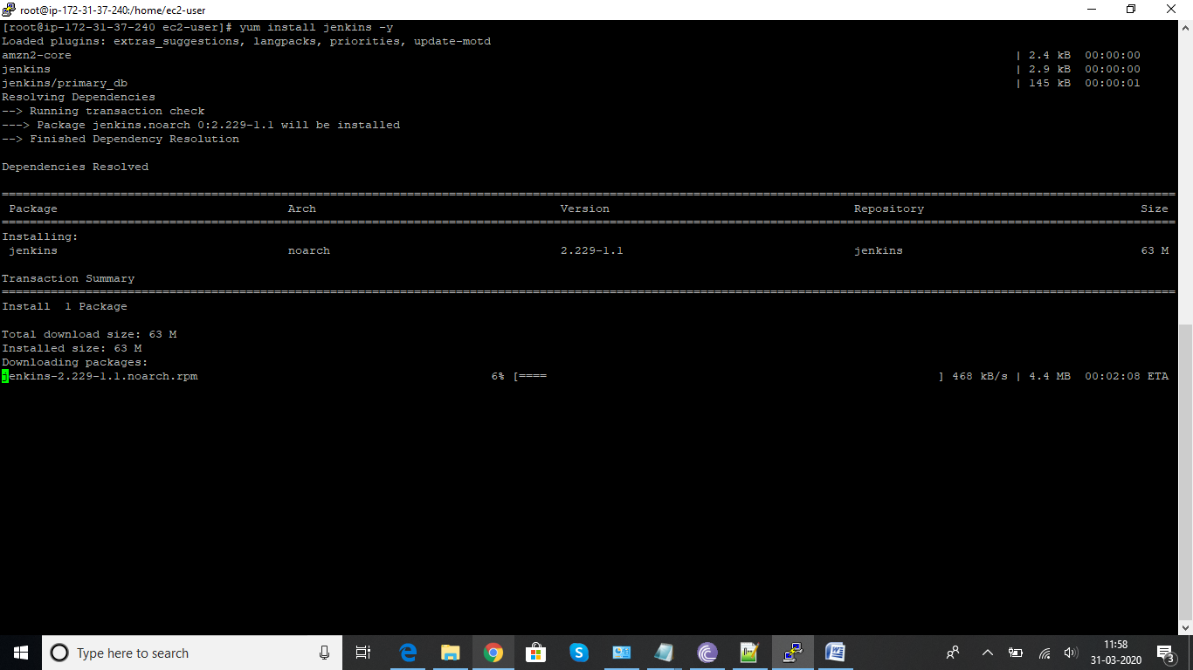
Jenkins started
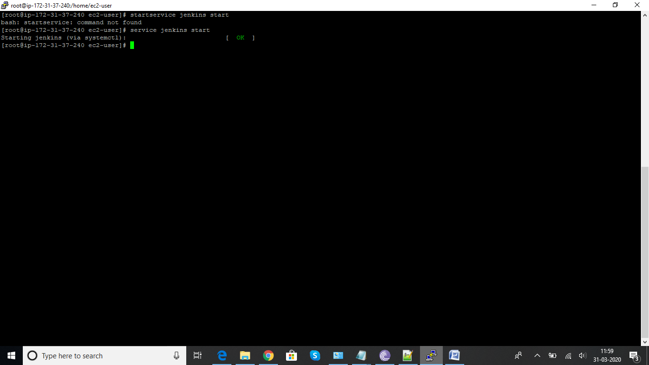

[ec2-user ~]$ systemctl start jenkins.service
[ec2-user ~]$ systemctl enable jenkins.service

Open the inboud security group and 8080 port to allow
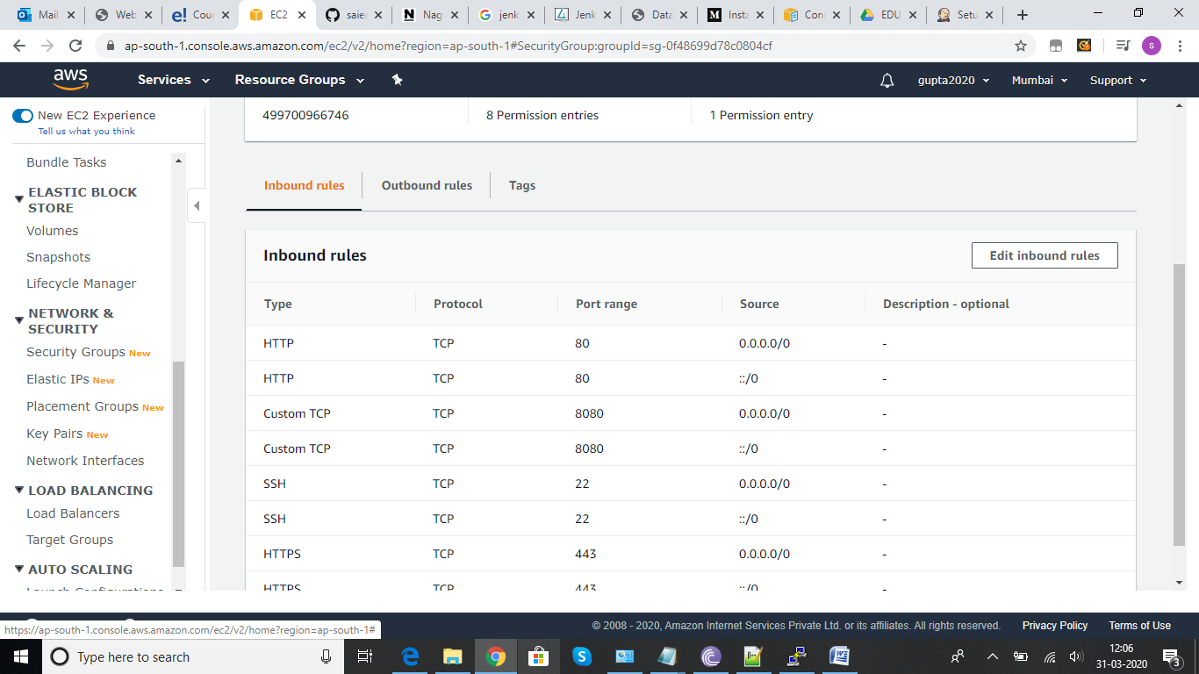

Login Jenkins with ipaddress:8080
Then do cat /var/lib/jenkins/secrets/initialAdminPassword
Password: xxxxxxxxxxx
Enter in jenkins password Colum
Will get the below page
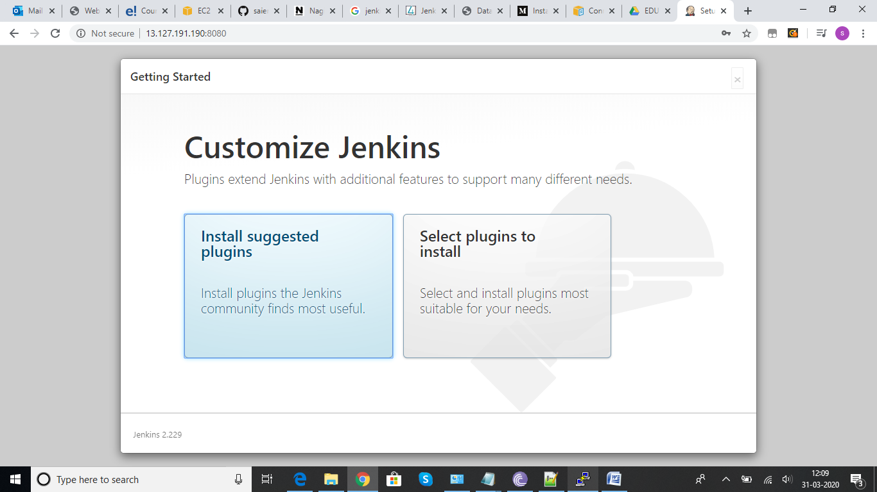

Click on suggested plugin…it will install default plugins
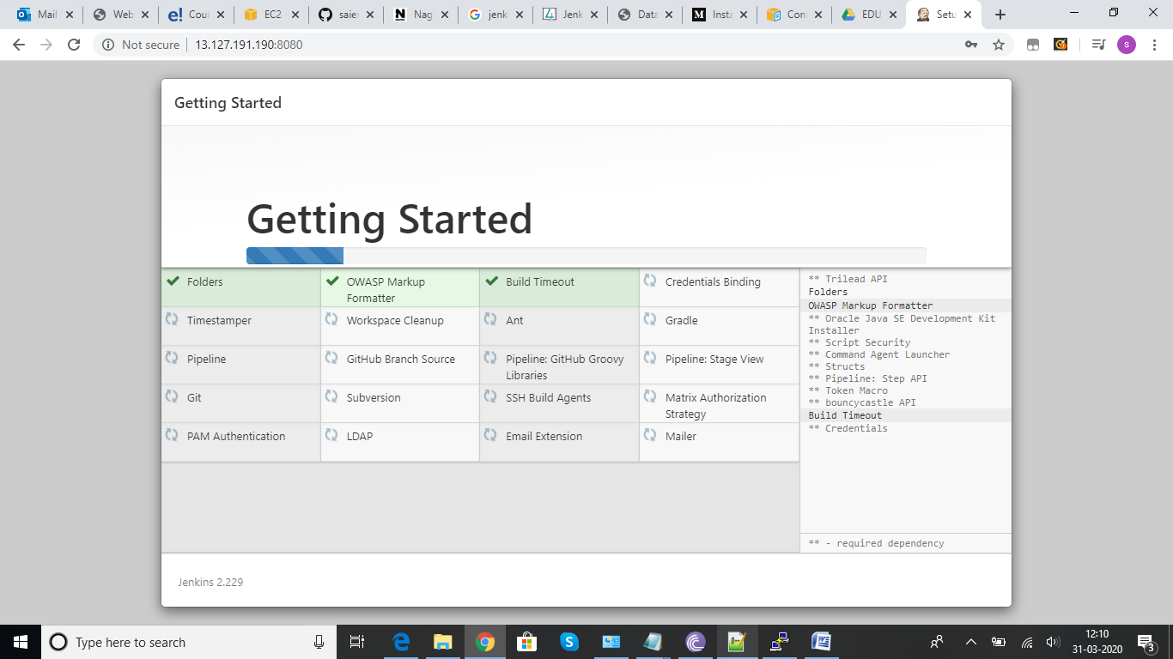

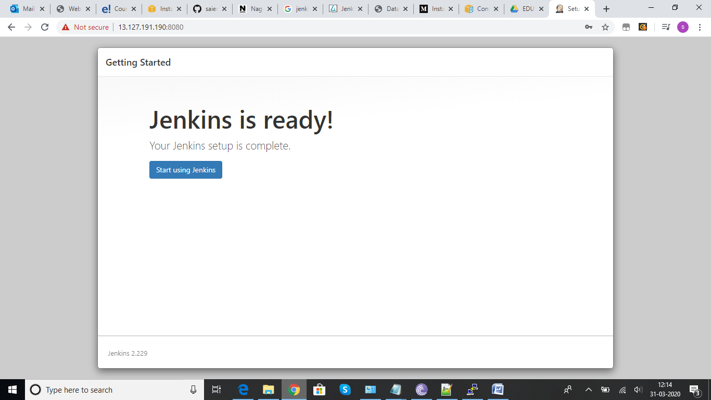

Creation of freestyle project…click on create now
Give the name and select freestyle
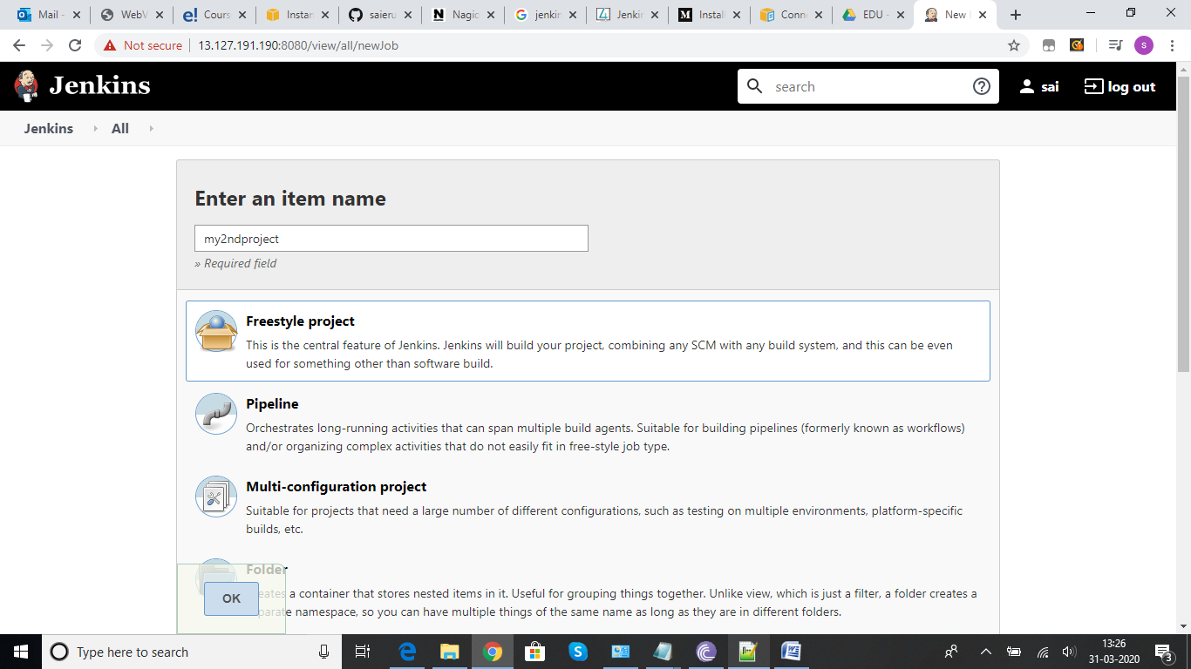

Using bash shell to run the build provided the required details , then save and apply
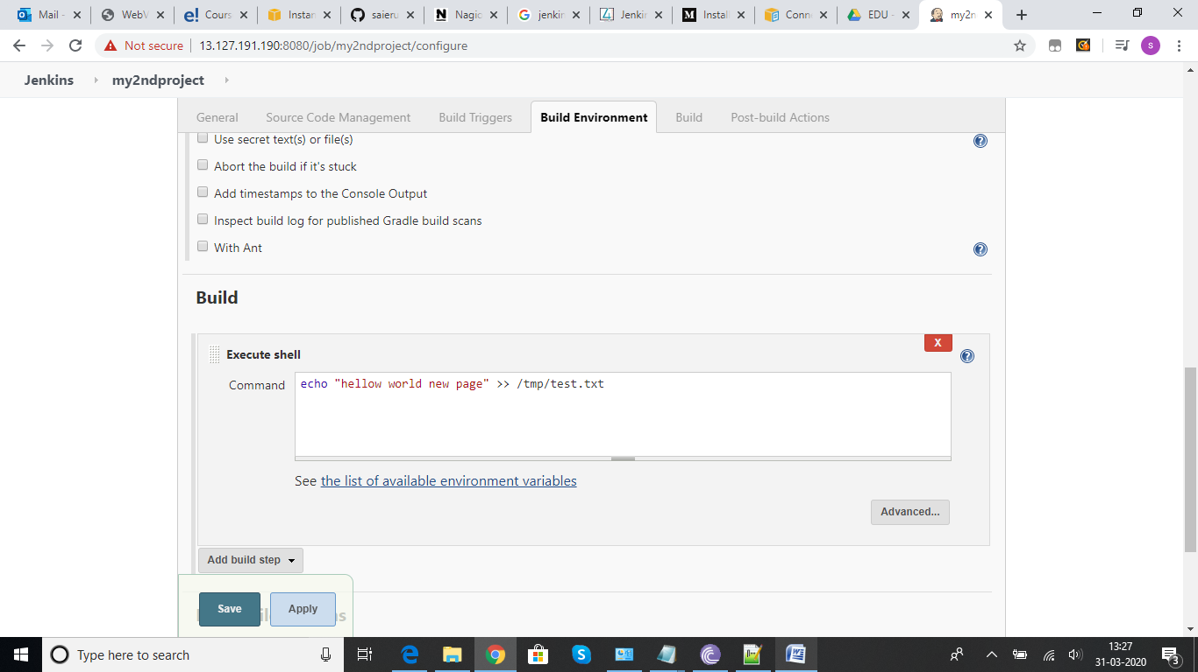
Then click on build now
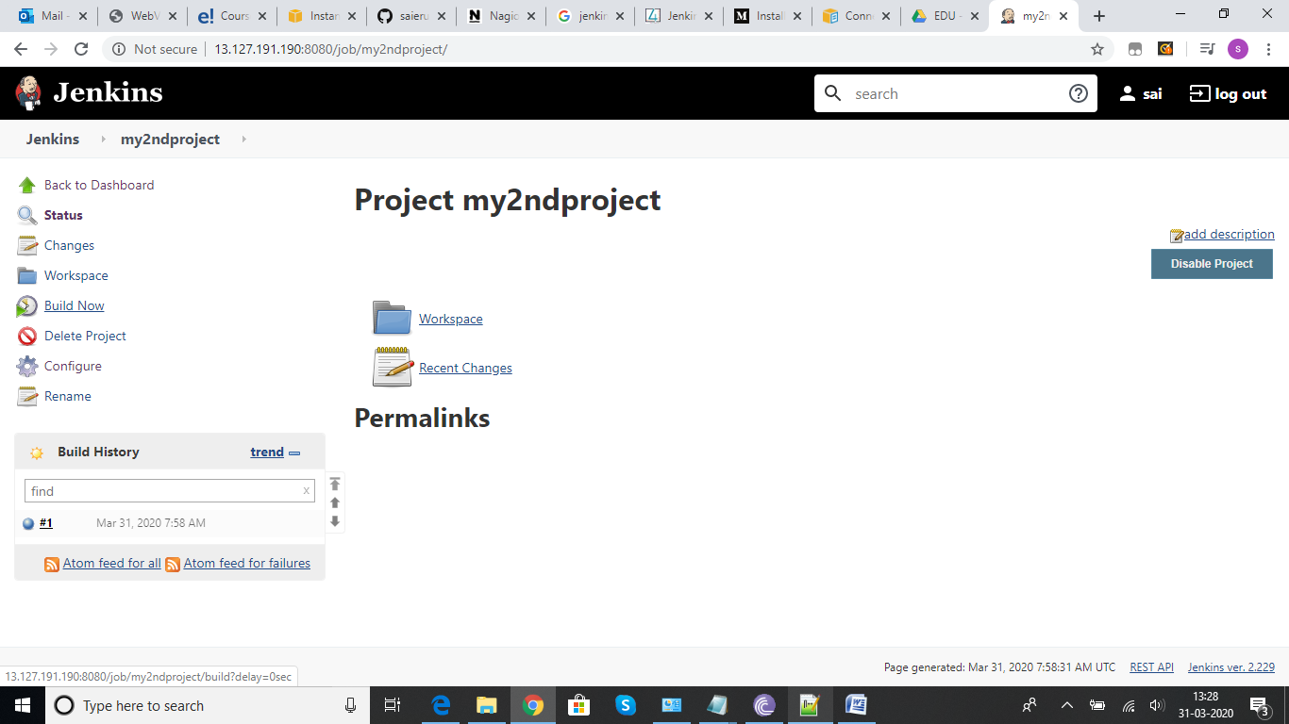
Console output
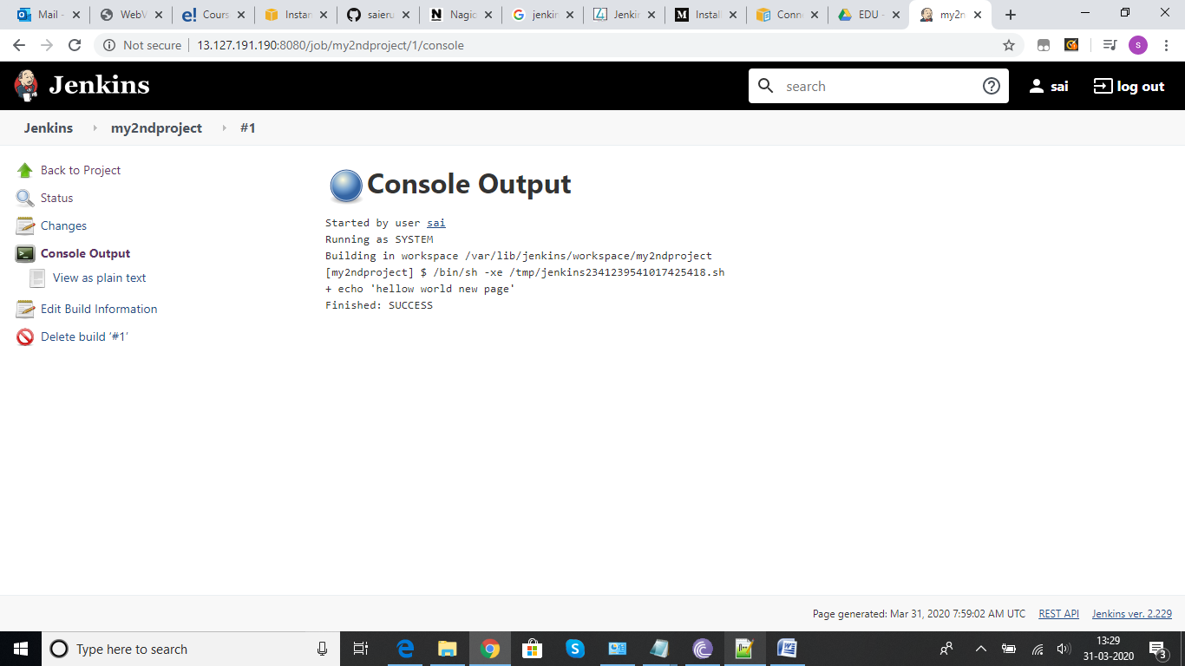

Poll SCM Build Triggers:
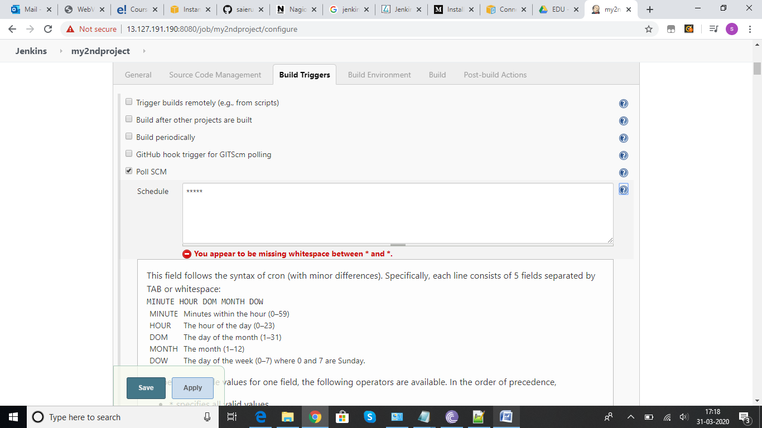
Poll scm has been setup for every minitue

Once setup poll scm polling log will appear on Jenkins project.
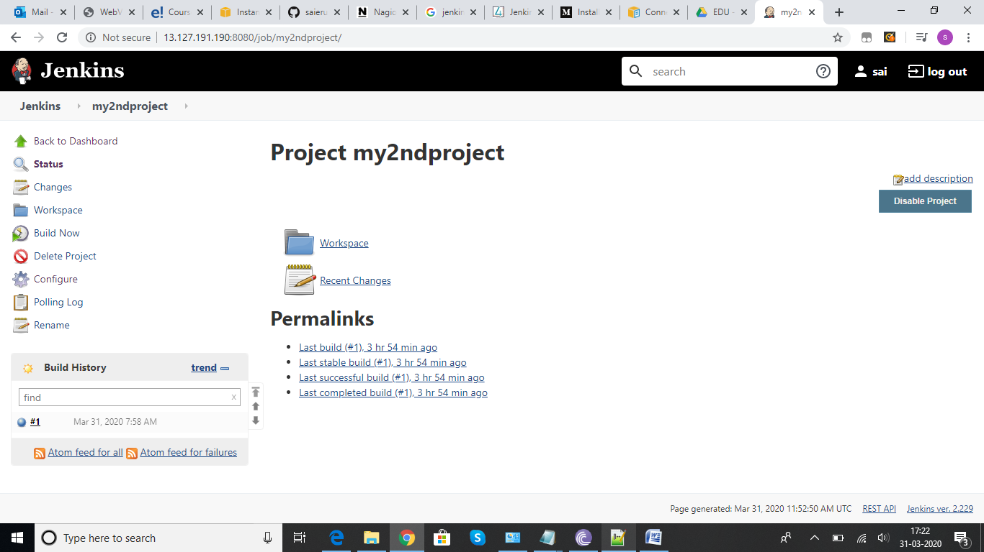

Automated testing in Jenkins using jmeter:

